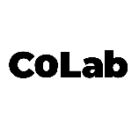

**Memorandum of Understanding (MoU)**

**This Memorandum of Understanding** ("MoU") is made on this 26.09.2024, by and between:

**CoLab**, acting as an e-commerce aggregator platform to showcase their products and services, (hereinafter referred to as "CoLab");

AND

**Enactus MH (Dharang) is** an independent entrepreneur operating in Indian handicrafts, residing at Miranda House, Maurice Nagar (hereinafter referred to as the "Entrepreneur").

Both parties are hereinafter collectively referred to as the "Parties" and individually as the "Party."

**1. Purpose of the MoU**

The purpose of this MoU is to establish the terms and conditions under which CoLab will provide its platform for the Entrepreneur to showcase and sell their products or services, and the Entrepreneur will contribute to the CoLab ecosystem by listing their products and collaborating with other entrepreneurs on the platform.

**2. Scope of Collaboration**

CoLab agrees to:

* Provide the Entrepreneur with access to the CoLab platform for listing, showcasing, and selling their products or services.
* Promote the Entrepreneur’s offerings within its network to increase visibility and reach.
* Facilitate collaborations between the Entrepreneur and other student-run ventures on the platform.

The Entrepreneur agrees to:

* List __ number of genuine and original products or services on the platform.
* Actively engage with the CoLab platform and community to maximize the collaboration potential.
* Provide accurate and up-to-date information regarding the products or services offered.

**3. Responsibilities of the Parties**

**CoLab’s Responsibilities:**

* Ensure that the platform remains functional and is accessible to all its registered entrepreneurs.
* Promote student entrepreneurs across relevant channels to help boost their market reach.
* Provide regular updates and potential opportunities for collaboration or investment.

**Entrepreneur’s Responsibilities:**

* Maintain the quality and accuracy of the products or services listed on the platform.
* Fulfill customer orders promptly and maintain open communication with customers.
* Comply with all applicable laws and regulations in relation to their business operations.

---------------------------------------------------------------------------------------------------------------

**Signed by:**

**For CoLab:**  
Date: 24.09.2024

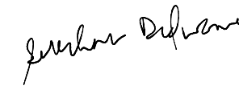

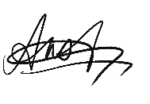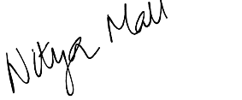

Ansh Agrawal Nitya Mall Saksham Didwania

(Co-Founder) (Co-Founder) (Co-Founder)

**For the Entrepreneur:**  
Name: Enactus MH  
Title: Dharang, Enactus MH  
Date: 26.09.2024